SECTION AND DEVELOPMENT OF SOLIDS
1. A pentagonal pyramid of base side 30 mm and axis length 80mm is resting on HP on its base with one of its base side parallel to VP. It is cut by a plane inclined at 30° to HP and perpendicular to VP and is bisecting the axis. Draw its front view, sectional top view, and the true shape of section.

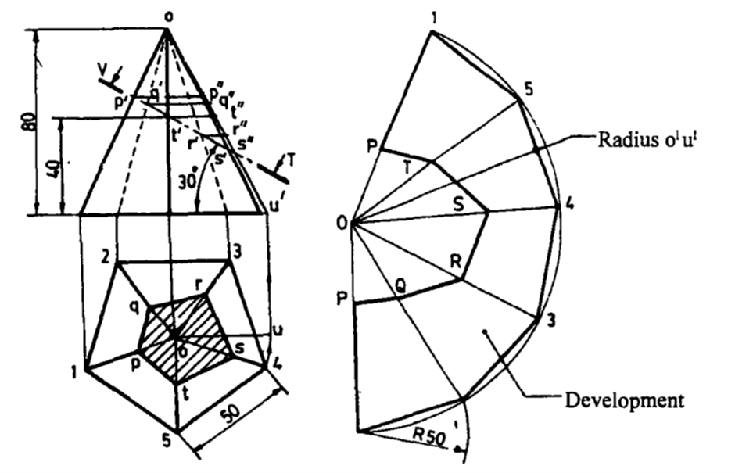

2. A square pyramid base 40mm side and axis 65mm long has its base on HP and all the edges of the base are equally inclined to VP. It is cut by a section plane perpendicular to VP and inclined at 45⁰ to HP and bisecting the axis. Draw its sectional plan, sectional end elevation and true shape of the section.

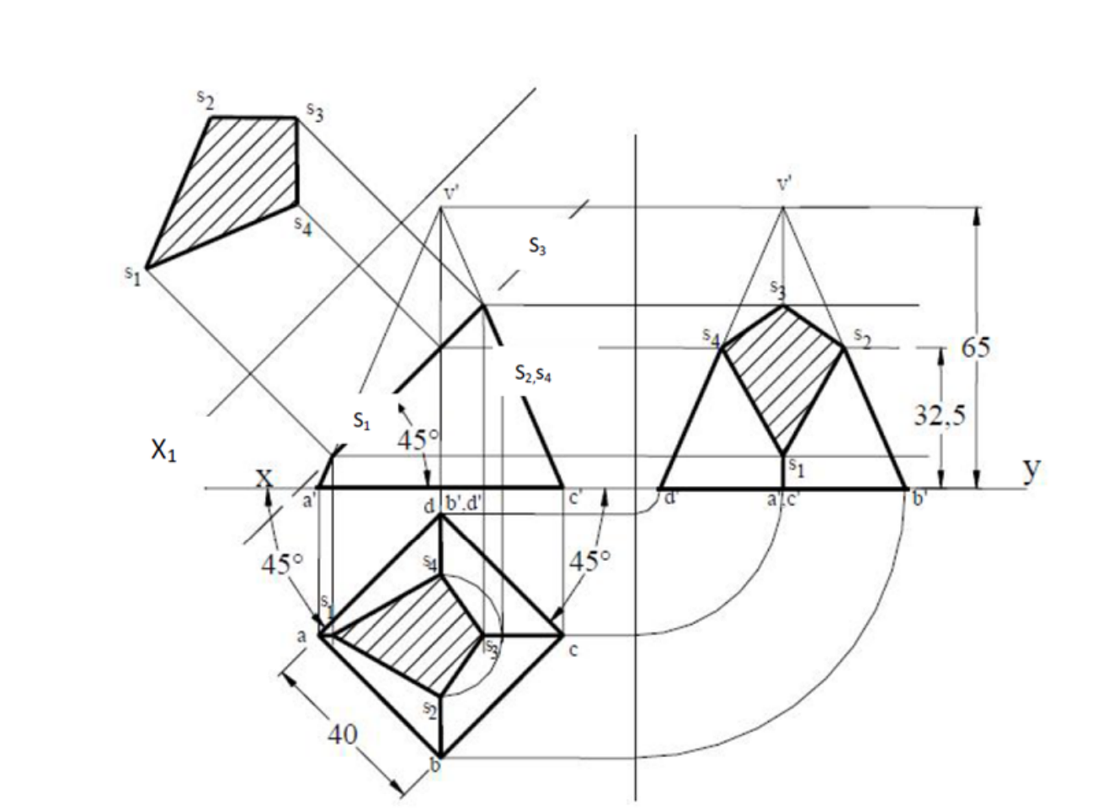

3. A square pyramid of base side 40 mm and height 75 mm has its base side equally inclined to V.P. It is cut by a plane perpendicular to V.P., 40 degrees to H.P. meeting the axis at a distance of 40 mm from the base. Draw the development of the lateral surface of the pyramid.
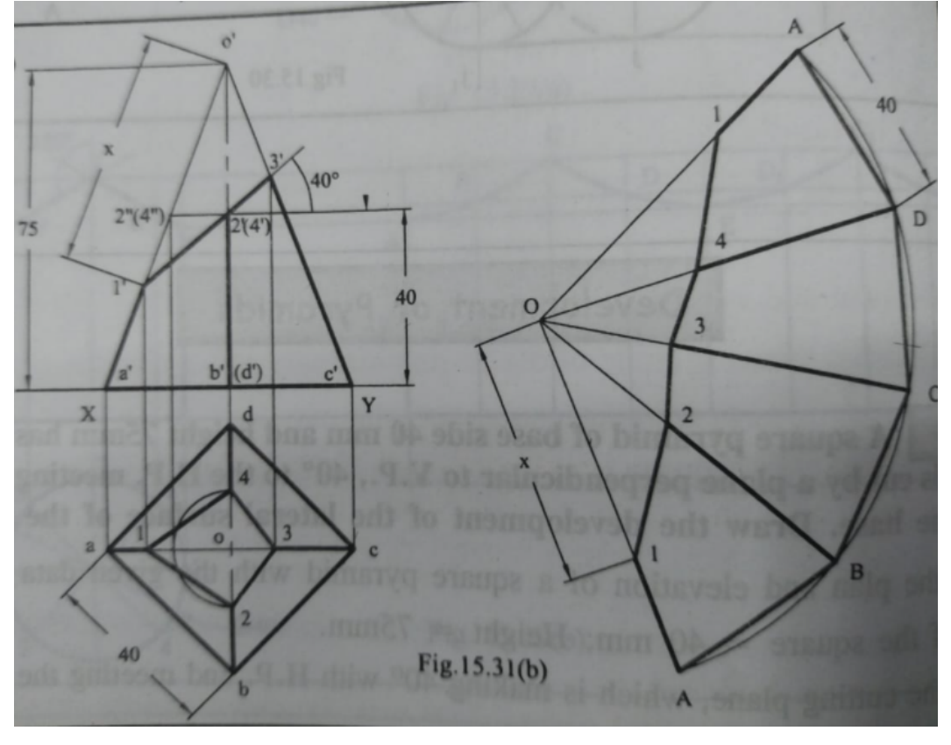

4. Draw the development of a cylinder of 60 mm diameter and 80 mm height containing a square hole of 30 mm side. The side of the hole are equally inclined to the base axis of the hole bisects the axis of cylinder.
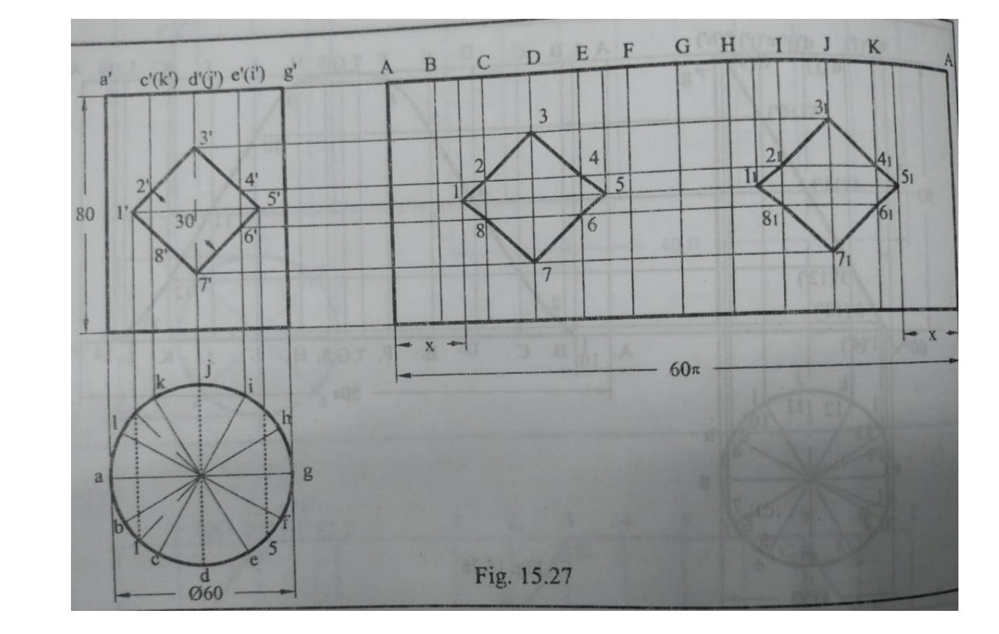

5. A hexagonal pyramid, base 30 mm side and axis 70 mm long is resting on its slant edge of the face on the horizontal plane. A section plane, perpendicular to the V.P., inclined to the H.P. passes through the highest corner of the base and intersects the axis at 25 mm from the base. Draw the projections of the solid and determine the inclination of the section plane with the H.P
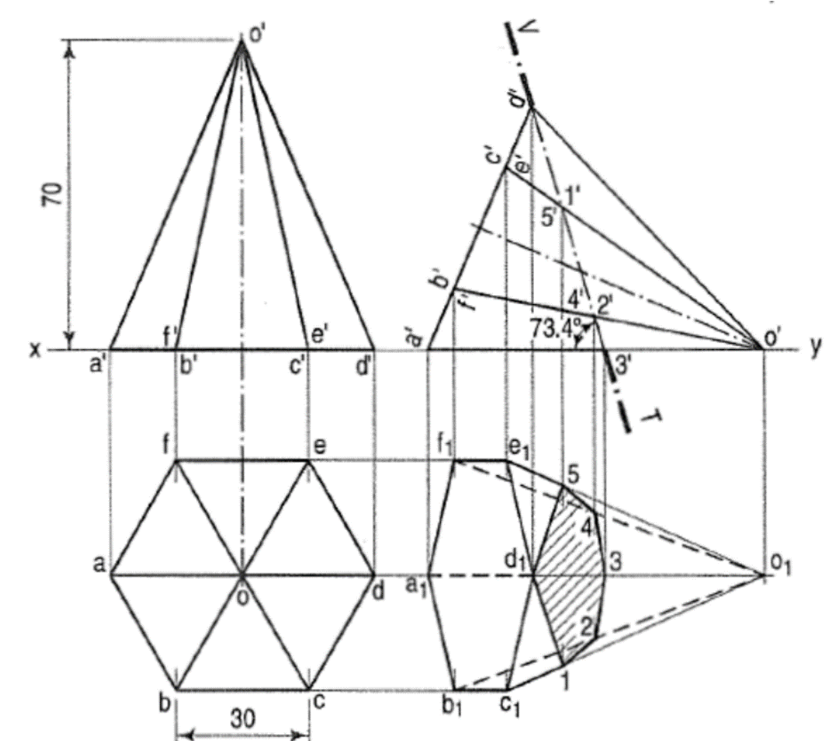

6. A hexagonal pyramid, base 30 mm side and axis 75 mm long, resting on its base on the HP. with two of its edges parallel to the V.P. is cut by two section planes both perpendicular to the V.P. The horizontal section plane cuts the axis at a point 35 mm from the apex. The other plane which makes an angle of 45° with the HP, also intersects the axis at the same point. Draw the front view, sectional top view, true shape of the section and development of the surface of the remaining part of the pyramid.

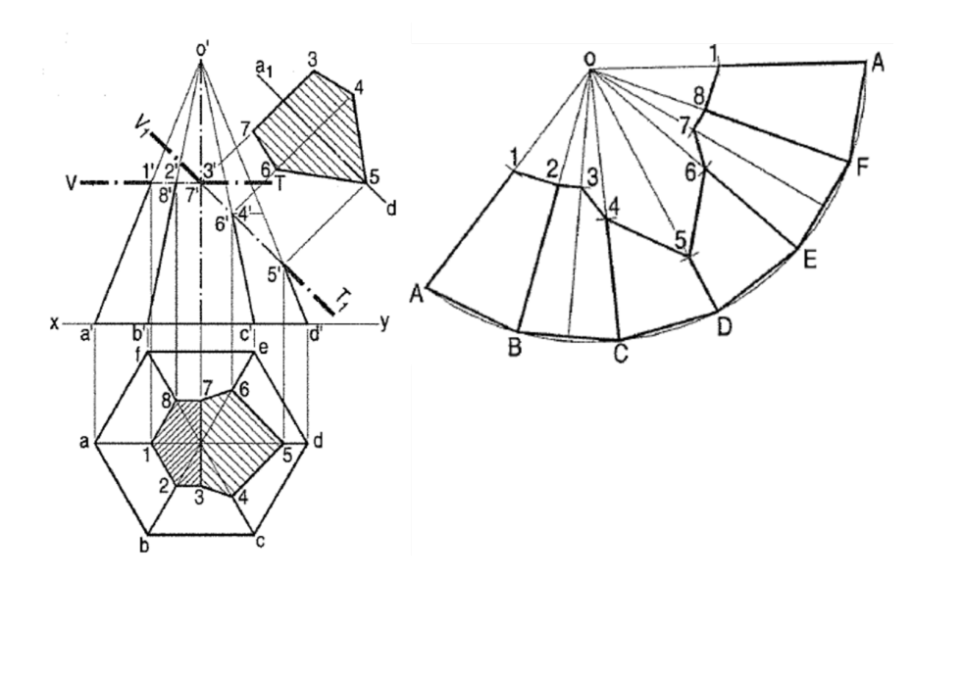

7. A triangular prism of side of base 25 and axis 65 long, rests on a corner of the base on H.P., with a base inclined at 60° to H.P. and a rectangular face perpendicular to V.P. A section plane perpendicular to H.P. and inclined at 30° to V.P., bisects the axis of the prism. Draw the projections and determine the true shape of the section.
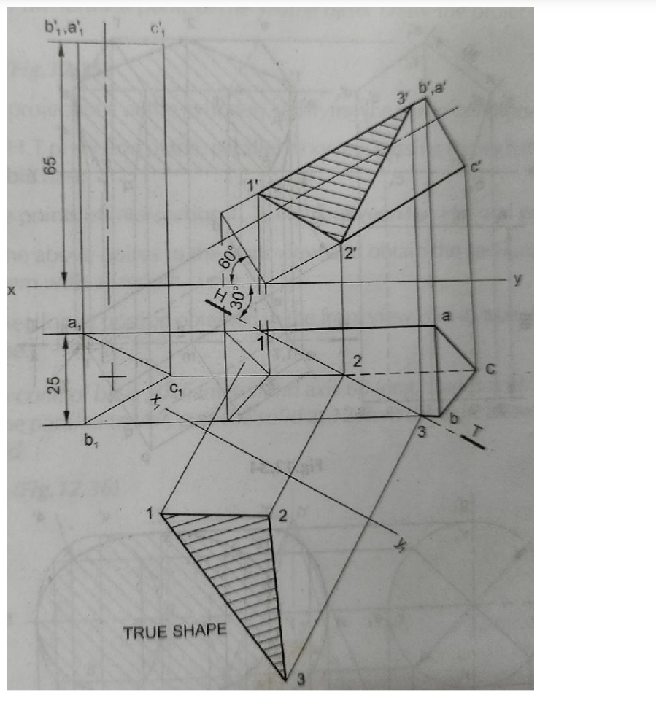

8. A right circular cone of base diameter 50 and axis 60 long, is resting on its base on H.P. A semi-circular hole of radius 15 is cut through the cone such that, the axis of the hole is perpendicular to V.P. and intersecting the axis of the cone at 20 above the base. The flat surface of the hole is parallel to H.P. Draw the development of the lateral surface of the cone.

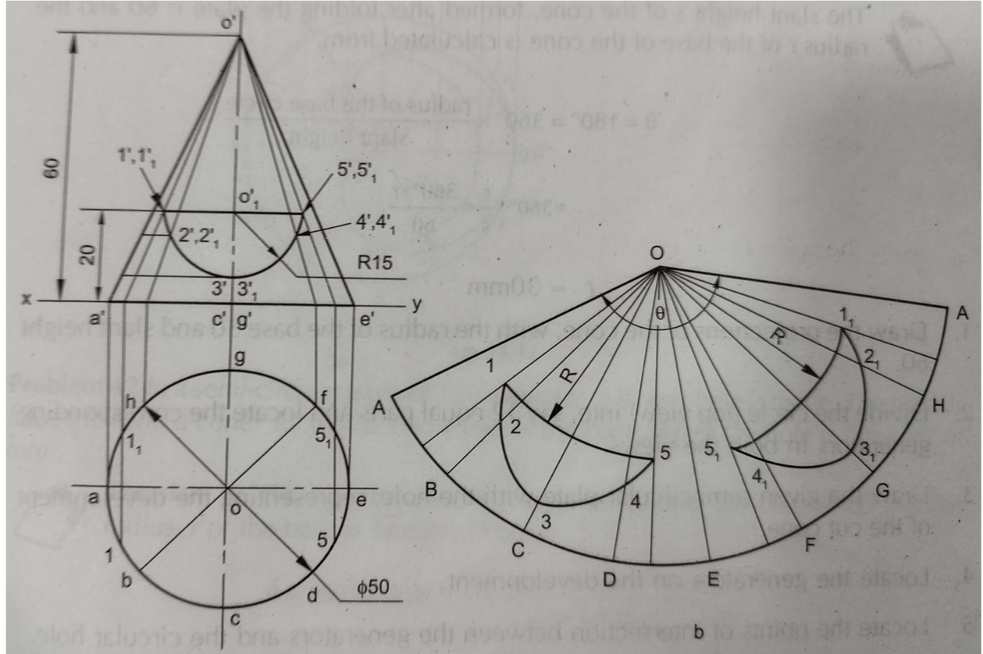

9. A hollow cylinder, outside diameter 48 mm, inside diameter 36 mm and height 56 mm, is resting on HP on its base. It is sectioned by a cutting plane to accommodate the maximum possible size of ellipse within it. Draw the sectional views (front, top and side views) and the true shape of the section. State the lengths (major & minor axis) of the ellipse & the inclination of the section plane
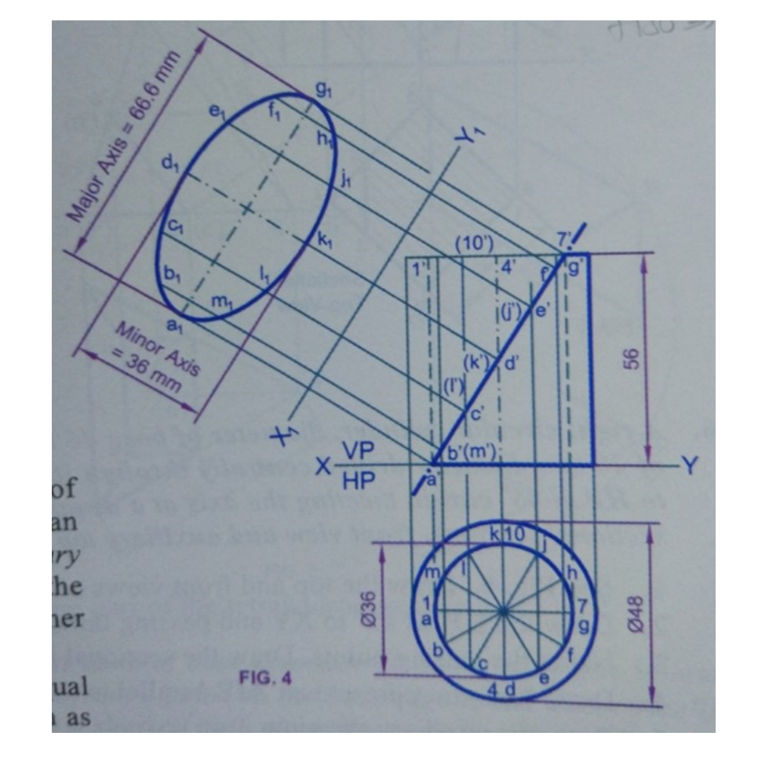

10. A cylinder of diameter 60 mm and height 80 mm has a central hexagonal slot of side 20 mm running right through the length. The cylinder is lying on the HP with its axis perpendicular to the VP. A vertical cutting plane cuts the cylinder in such a way that it meets the bases at 6 mm from diametrically opposite ends. Draw the sectional front view and the true shape of the section.



